Moch. Naufal Ardian Ramadhan  
15  
SIB 1G

**Jobsheet 9**

**2.1 Experiment 1: Fill in Array Element  
  
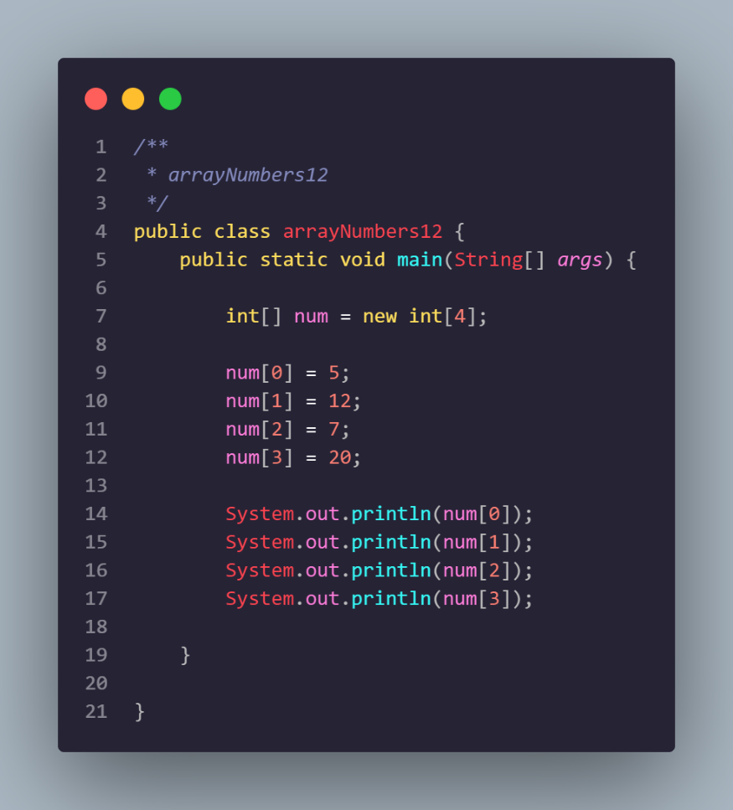**

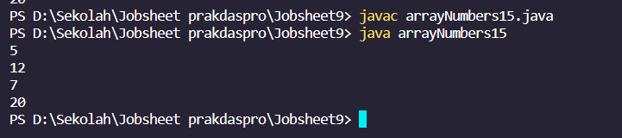

Question 1

1. If the contents of each element of the array num are changed with numbers 5.0, 12867, 7.5, 2000000. What happens? How can it be like that?

Cant run because the type data is int not double so cant run the program, if you want to run the program you must change from int type data to double type data